Git Challenges

1. Resolve Merge Conflicts
Purpose: Create and switch to a new branch.
git checkout -b feature1
Purpose: Create another branch for conflict testing.
git checkout -b feature2
Purpose: Merge the feature branch.
git merge feature1
Purpose: Check conflicted files.
git status
Purpose: Mark conflicts as resolved.
git add .
Purpose: Save the resolved merge.
git commit -m "Resolved merge conflict"
Purpose: Push the changes to GitHub.
git push origin main
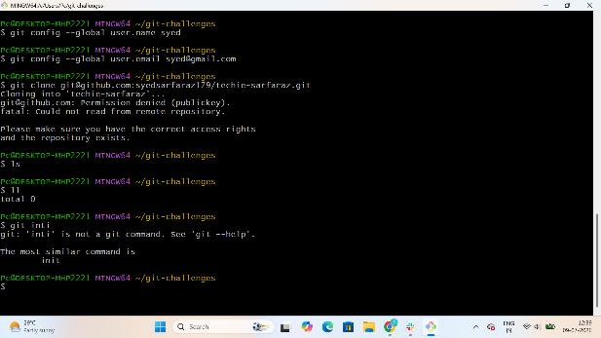
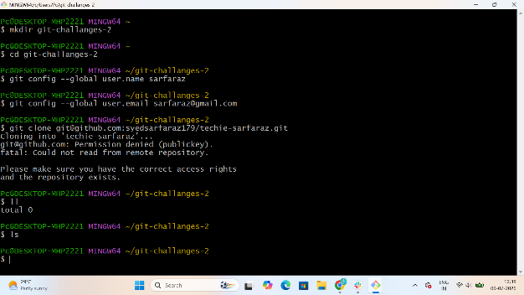
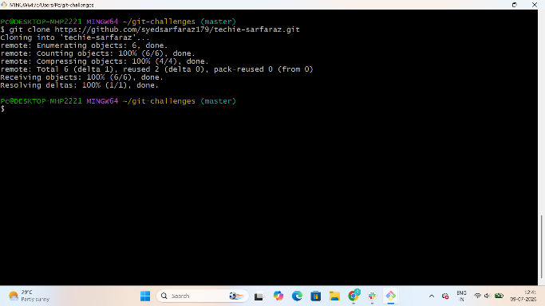
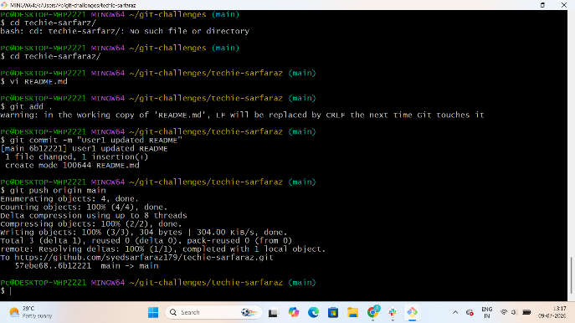
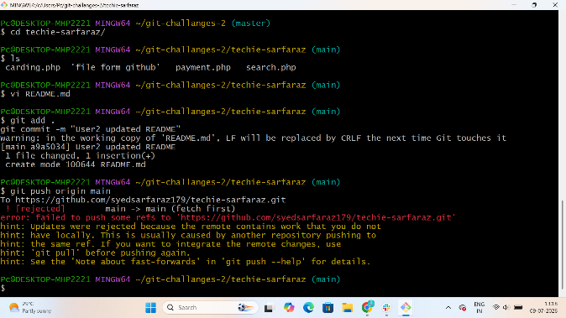
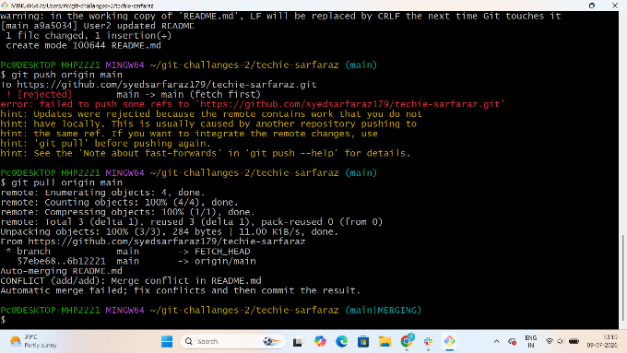

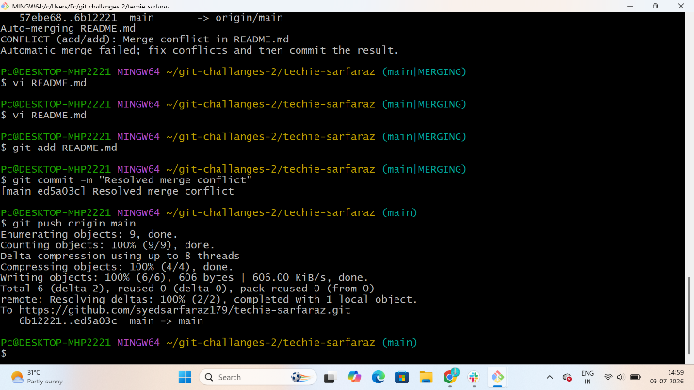
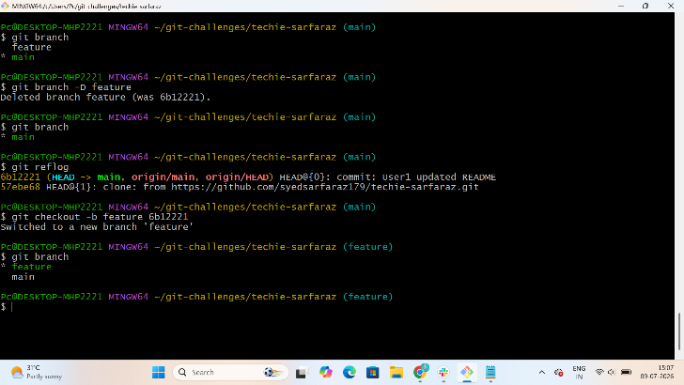
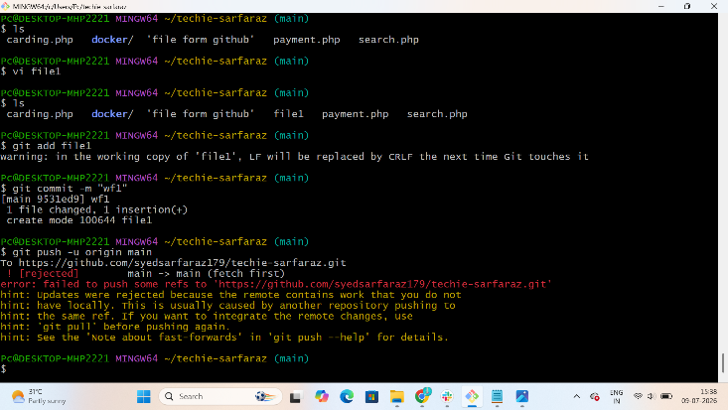
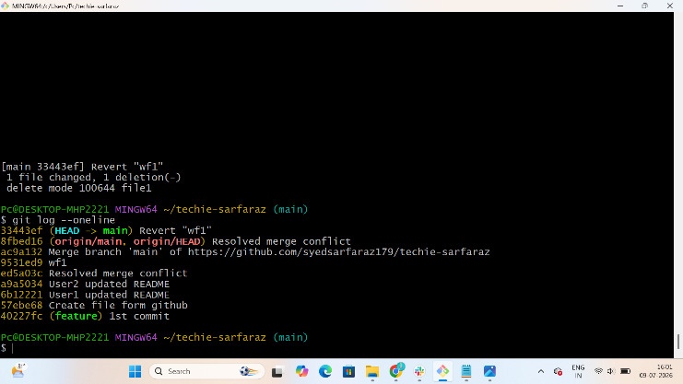
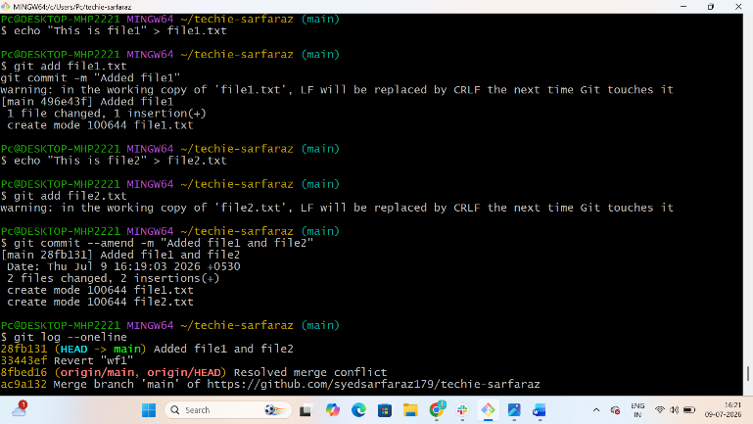

2. Recover Deleted Branch
Purpose: Delete the local branch.
git branch -D feature-demo
Purpose: Find the deleted branch commit.
git reflog
Purpose: Recover the deleted branch.
git checkout -b feature-demo <commit-id>
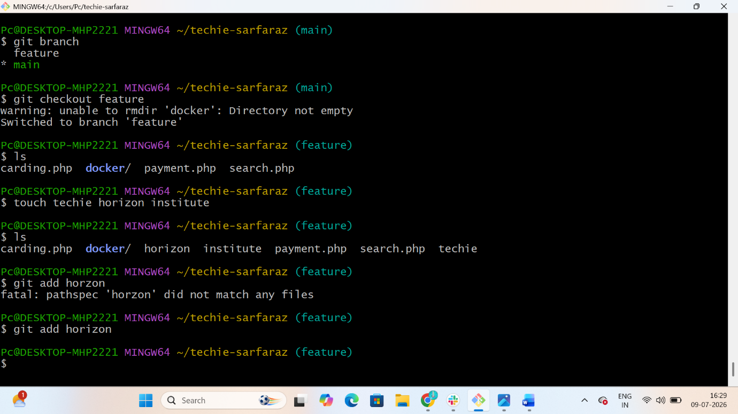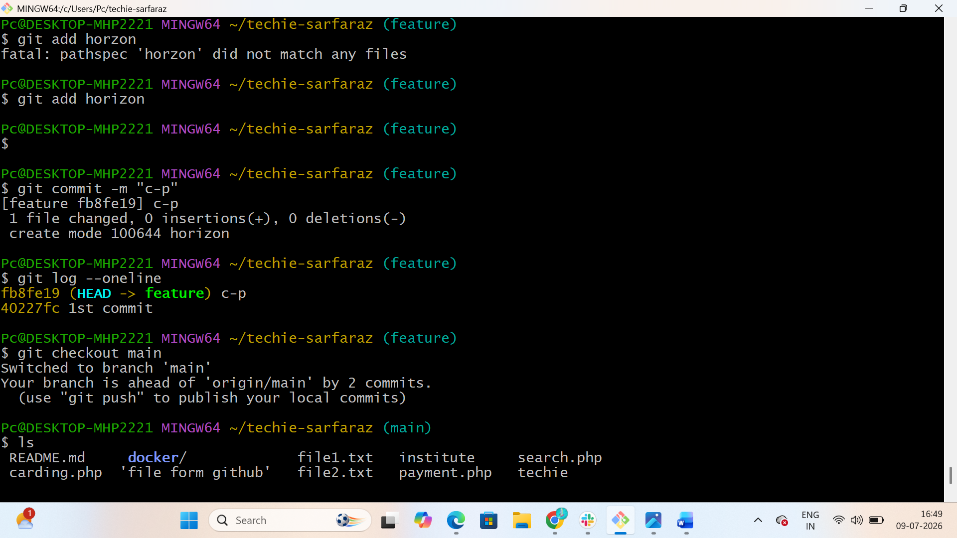

3. Undo Wrong Push
Purpose: Create a new commit that undoes the wrong commit.
git revert <commit-id>
Purpose: Push the revert commit.
git push origin main

4. Amend a Commit
Purpose: Stage the missing file.
git add .
Purpose: Add the missing file to the previous commit.
git commit --amend
Purpose: Update the remote repository.
git push --force

5. Cherry-pick a Commit
Purpose: View commit IDs.
git log --oneline
Purpose: Switch to the target branch.
git checkout main
Purpose: Apply the selected commit.
git cherry-pick <commit-id>

6. Interactive Rebase
Purpose: Open interactive rebase.
git rebase -i HEAD~3
Purpose: Update GitHub after rewriting history.
git push --force

7. Tagging & Release
Purpose: Create a version tag.
git tag v1.0
Purpose: Push the tag to GitHub.
git push origin v1.0
Purpose: Delete the local tag.
git tag -d v1.0
Purpose: Delete the remote tag.
git push origin --delete v1.0
Purpose: Recreate the tag.
git tag v1.0
Purpose: Push the recreated tag.
git push origin v1.0

8. Clone with Sparse Checkout
Purpose: Clone the repository without checking out files.
git clone --no-checkout <repo-url>
Purpose: Move into the repository.
cd <repo-name>
Purpose: Enable sparse checkout.
git sparse-checkout init --cone
Purpose: Download only the required folder.
git sparse-checkout set docker
Purpose: Checkout the main branch.
git checkout main

9. Reset vs Revert Challenge
Purpose: Remove the latest commit from local history.
git reset --hard HEAD~1
Purpose: Undo a commit while preserving history.
git revert <commit-id>

10. Detached HEAD Challenge
Purpose: View commit history.
git log --oneline
Purpose: Checkout a specific commit.
git checkout <commit-id>
Purpose: Create a new branch from the detached HEAD.
git checkout -b recovery-branch

11. Git Hooks Challenge
Purpose: Create or edit the commit hook.
vi .git/hooks/commit-msg
Purpose: Make the hook executable.
chmod +x .git/hooks/commit-msg
Purpose: Test the hook with a valid commit message.
git commit -m "JIRA-101 Initial Commit"

12. Squash Merge vs Rebase Merge
Purpose: Squash all feature branch commits into one.
git merge --squash feature-squash
Purpose: Save the squash merge.
git commit -m "Squash Merge"
Purpose: Rebase commits onto the latest main branch.
git rebase main
Purpose: Merge the rebased branch.
git merge feature-rebase

13. Fork & Pull Request Workflow
Purpose: Clone your forked repository.
git clone <fork-url>
Purpose: Create a feature branch.
git checkout -b feature-update
Purpose: Stage the changes.
git add .
Purpose: Commit the changes.
git commit -m "JIRA-301 Updated README"
Purpose: Push the feature branch.
git push origin feature-update

14. Recover Lost Commit
Purpose: Create a new commit.
git commit -m "JIRA-401 Recover Demo"
Purpose: Delete the latest commit.
git reset --hard HEAD~1
Purpose: Find the deleted commit.
git reflog
Purpose: Recover the deleted commit.
git reset --hard <commit-id>

